PC-CENTRE

*User Guide*

|  |  |  |
| --- | --- | --- |
| **Supervisor.** | Abdul Wahab | |
| **Batch.** | 2112F1 | |
| **Group.** | B | |
| **Serial No.** | **Enrollment Number** | **Student Name** |
|  | Student1355396 | Muhammad Abrar |
|  | Student1356120 | Tayyab |
|  | Student1351537 | Rafay |
|  | Student1352926 | Muhammad Mubashir |
|  | Student1355418 | Muhaamad Hassan Tahir Ali |

***User Guide***

1. **Home Page** (Pc-centre_home_page.html)

Figure 1: Home Page of Handikrafts

**Features of Home Page:**

* First of all, user can see the smooth and Sticky Navigation Bar with Some Logos.
* When the user click the **Home** Button, user redirect on this page and when click **About** **Us** Button, he can see the some details for our mission etc.. and when user click on **Contact Information** he can also see some information about timings etc. And he can also see the Contact us form and he can also seen Site map. When user Click on **Gallery** button he can see the some products of our pc-centre and see some details like as price etc.
* When the user clicks the “Pc-Centre Products”, Dropdown is open with Sliding Animation and show Products of Pc-Centre.
* Automatic beautiful Pc-Centre Products Image Slider runs. The Description of the products also mentioned in Slider images as show above figure.

**Search bar**



.

1. **About us Page (**aboutus.html**)**

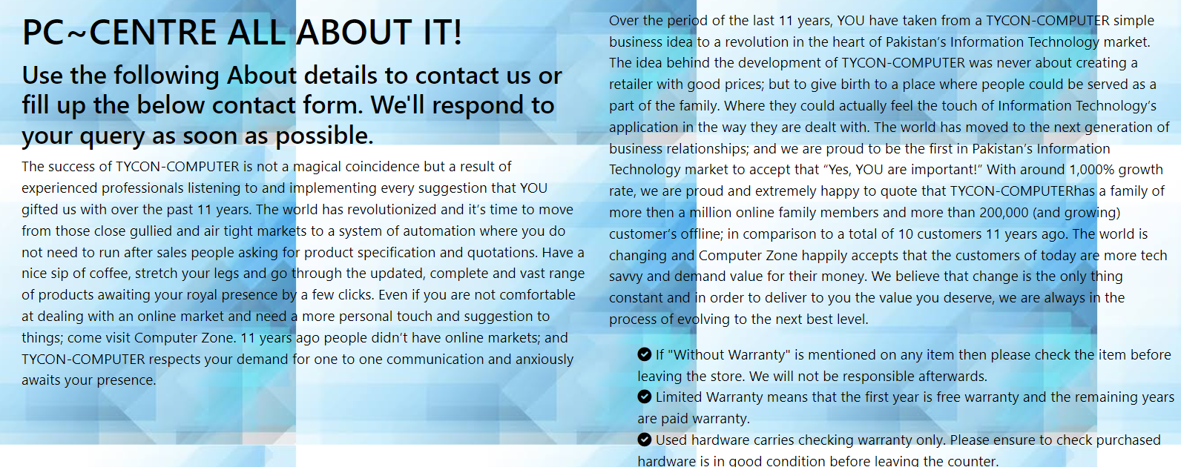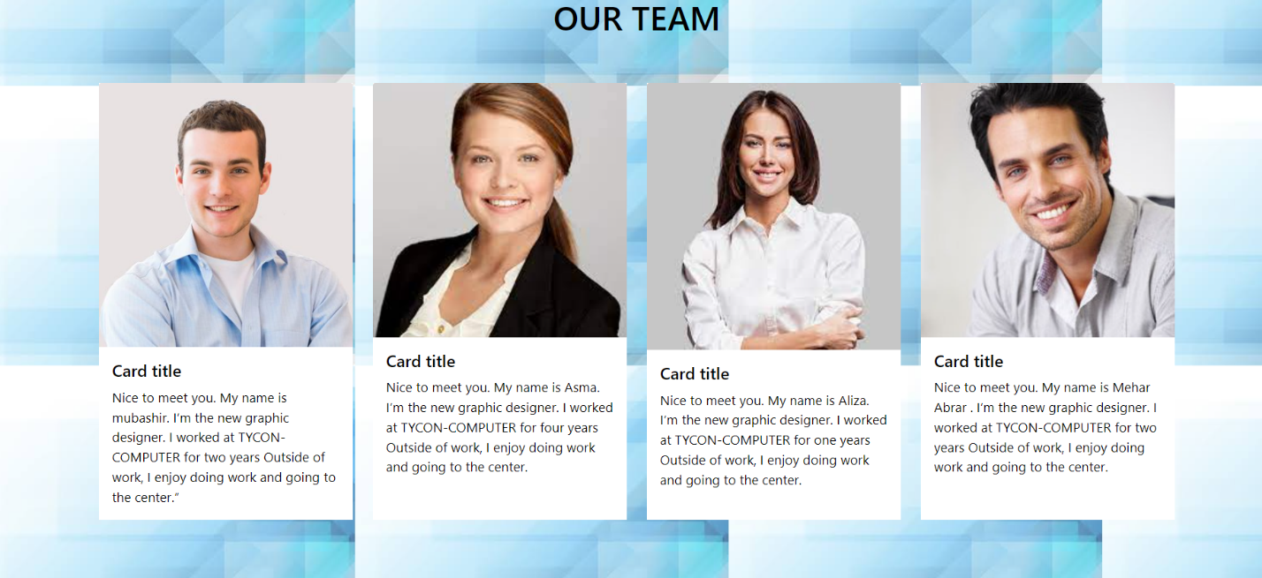

Figure 2 About us Page (As we described above)

1. **Contact Information Page** (contact.html)

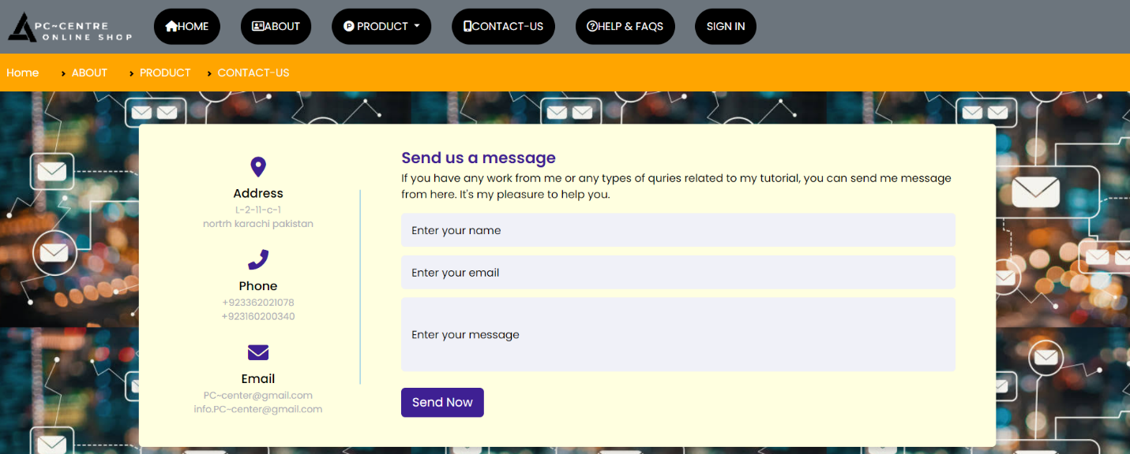

Figure 3 Contact Information page (As we described Above)

1. **Gallery** (Gallery.html)

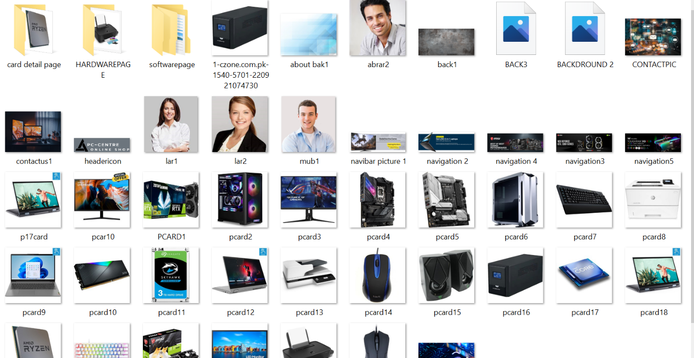

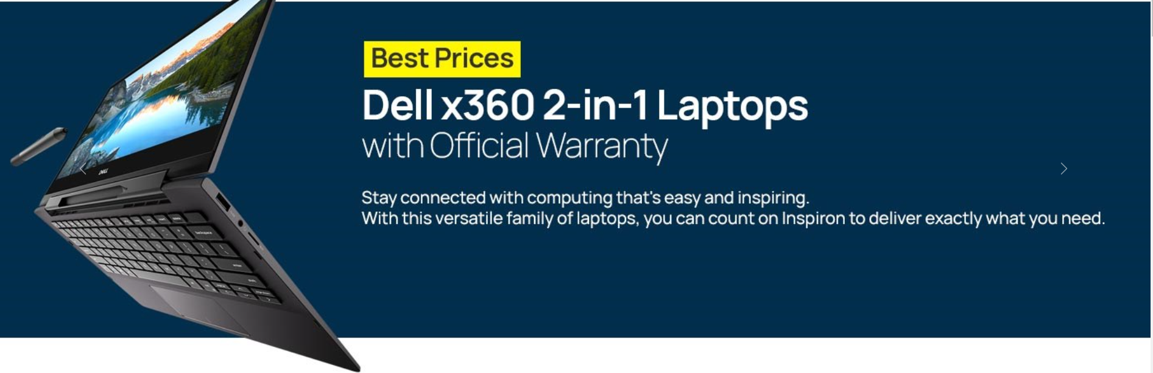

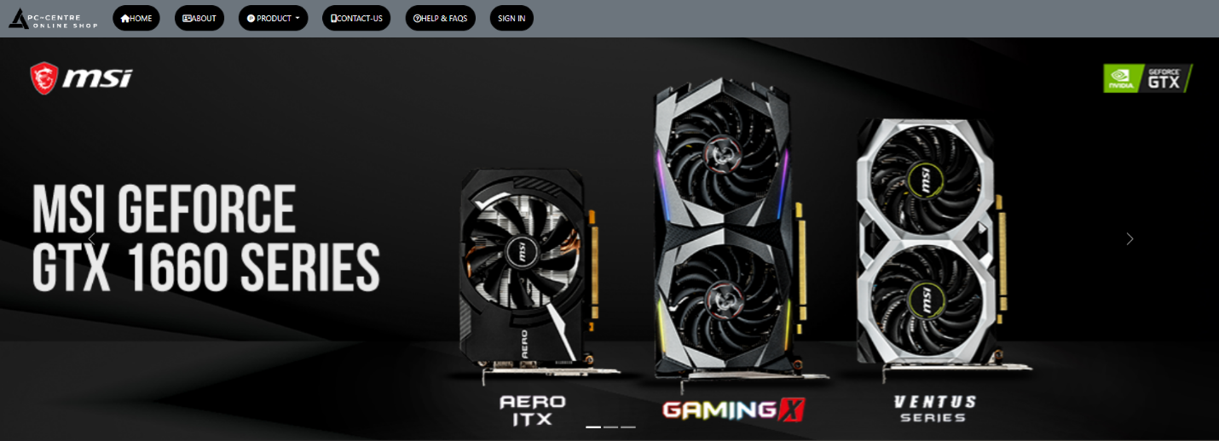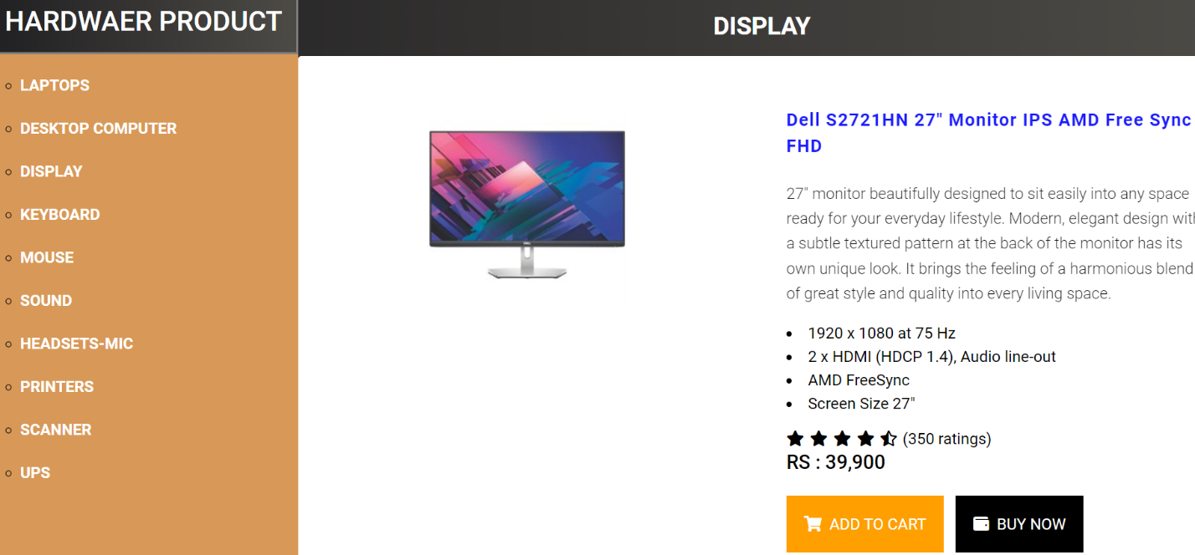

1. **Login Page** (Login.html)

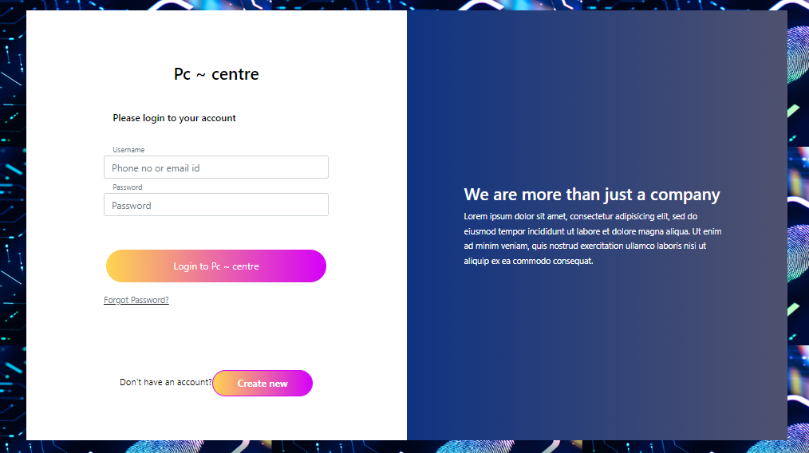

Login page (When User click on "User Logo", He can see this Login Page)

* When user Click on **“Forget Your Password??”** He can see the forget password Page As shown below.

1. **Forget Page** (Forget.html)

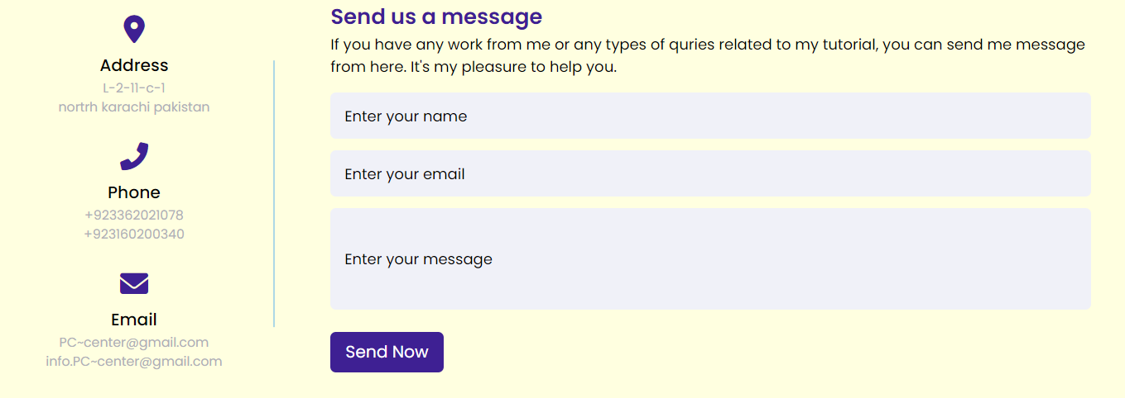

* When user click on **“Create Account”** he can see the create a account.

**Create Account Page** (Create.html)

* When user click the **“Cart Logo”** he can see the cart page.

**Cart (ADD TO CART)** (cart.html)

* When user Click **“PC-CENTRE Products”** he can see dropdown,

As show below,



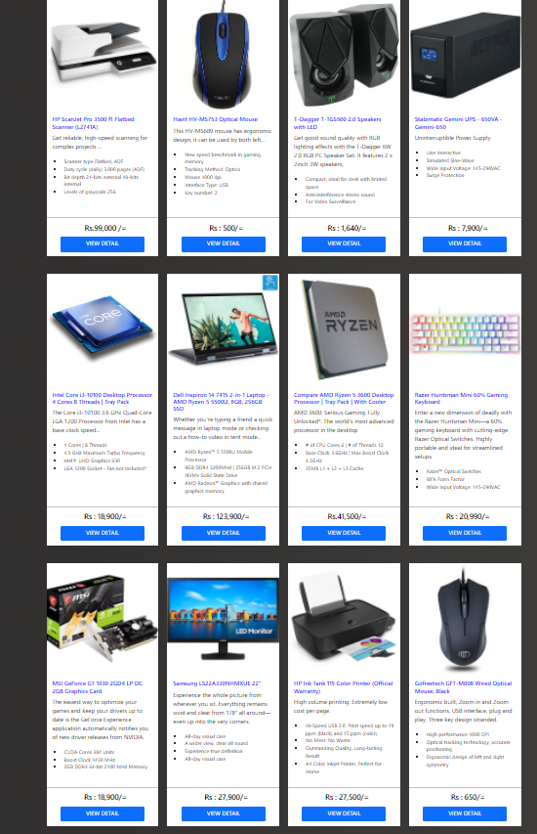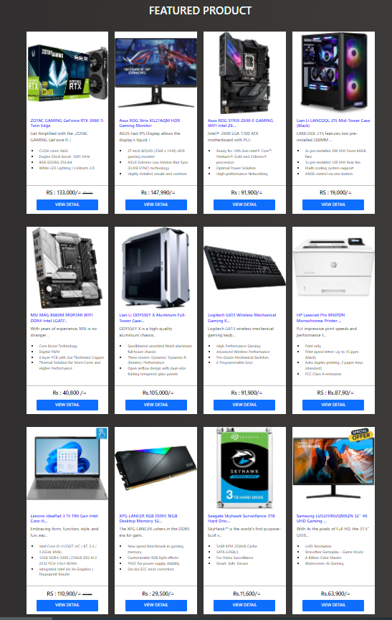



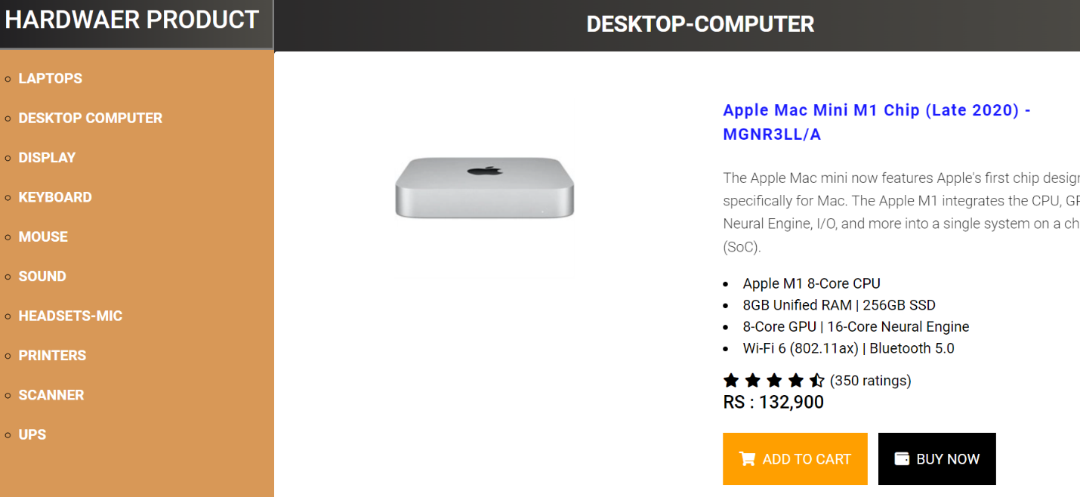

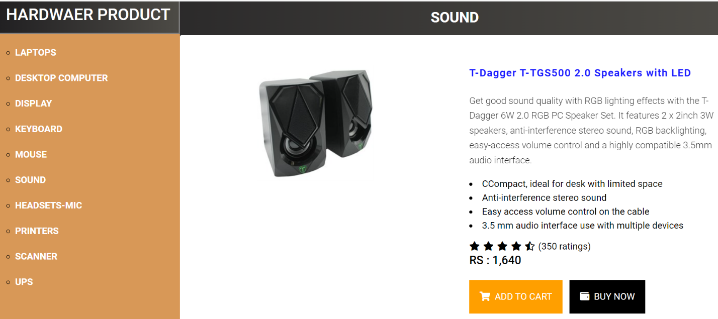

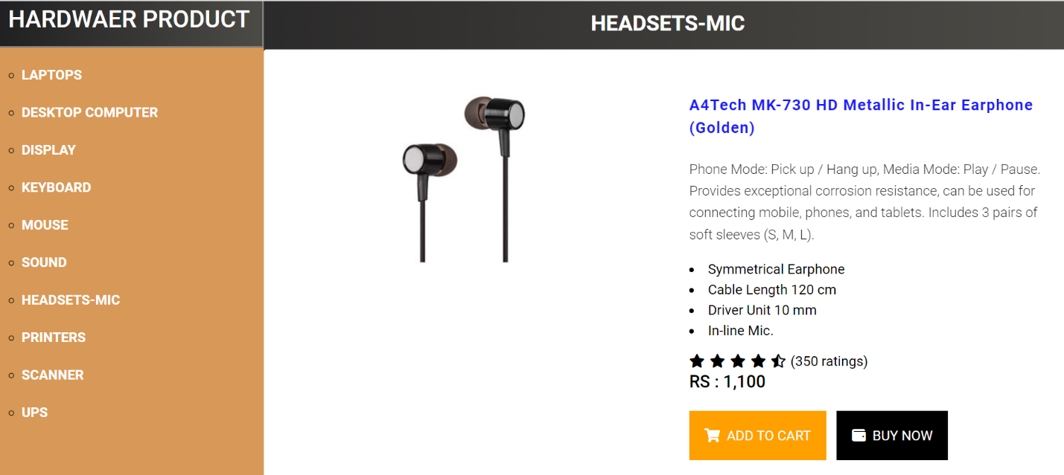

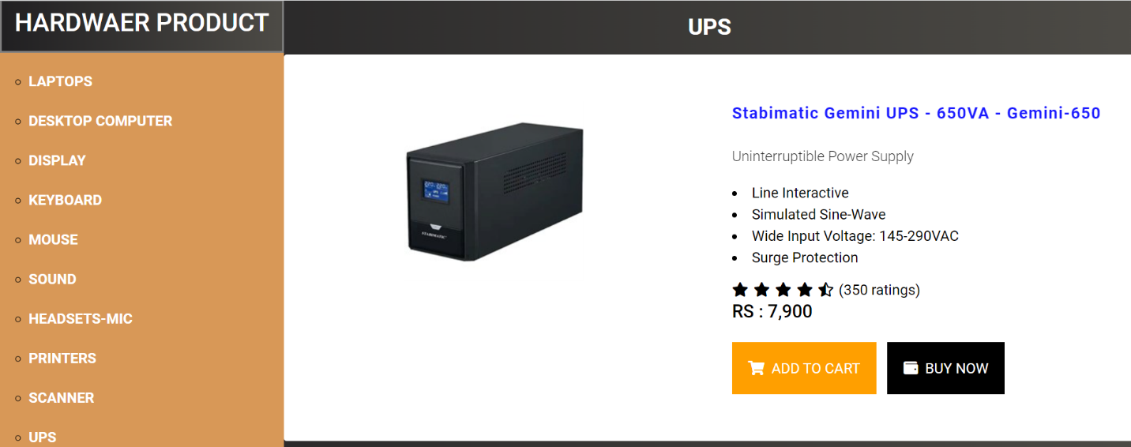

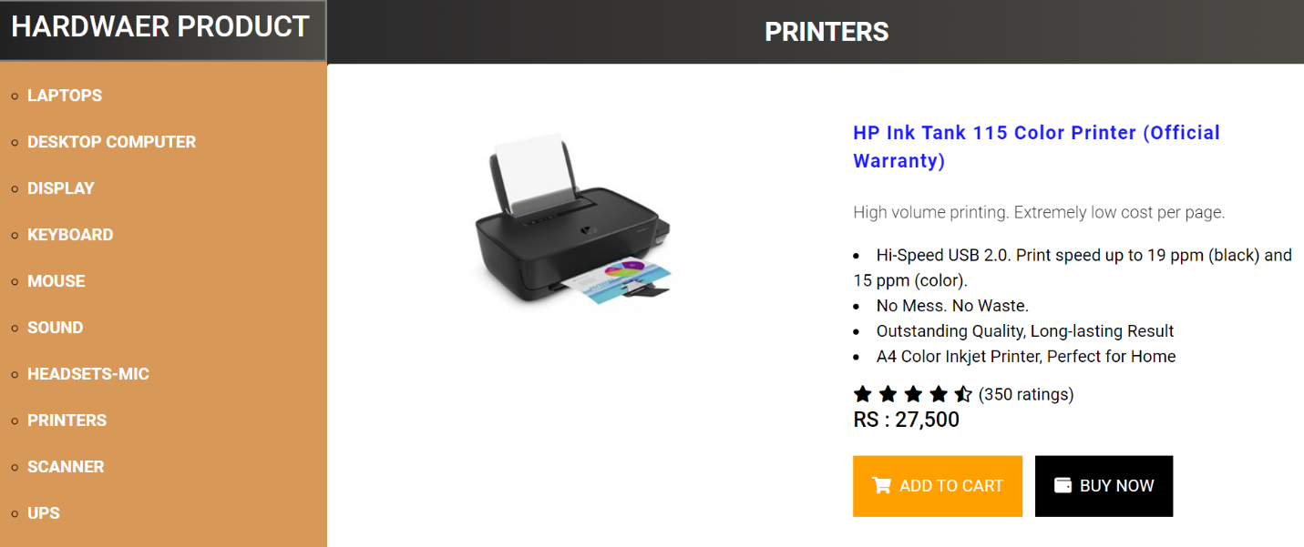

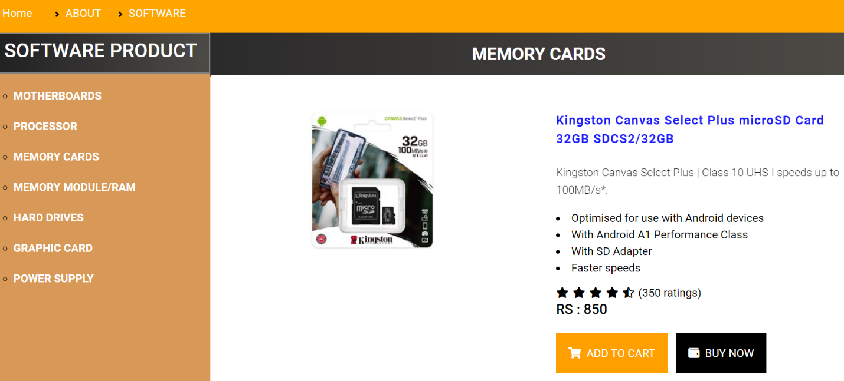

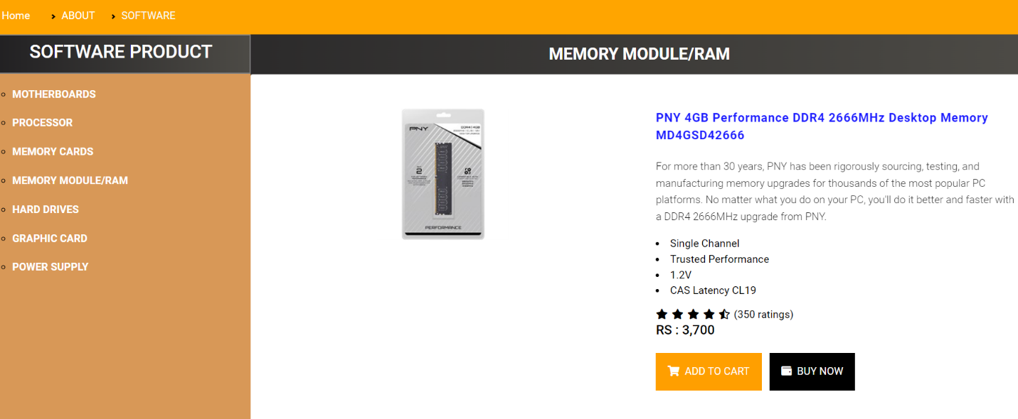

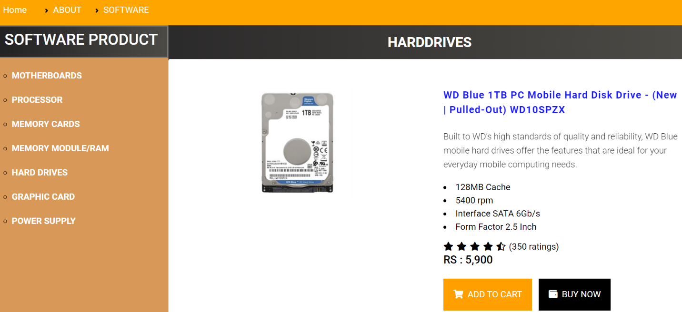

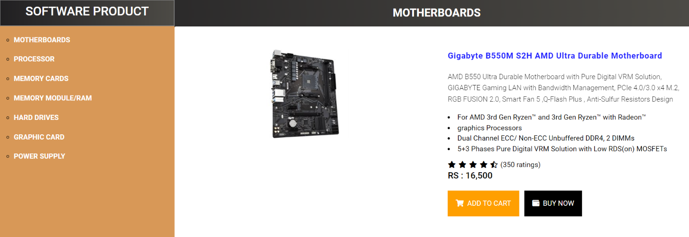

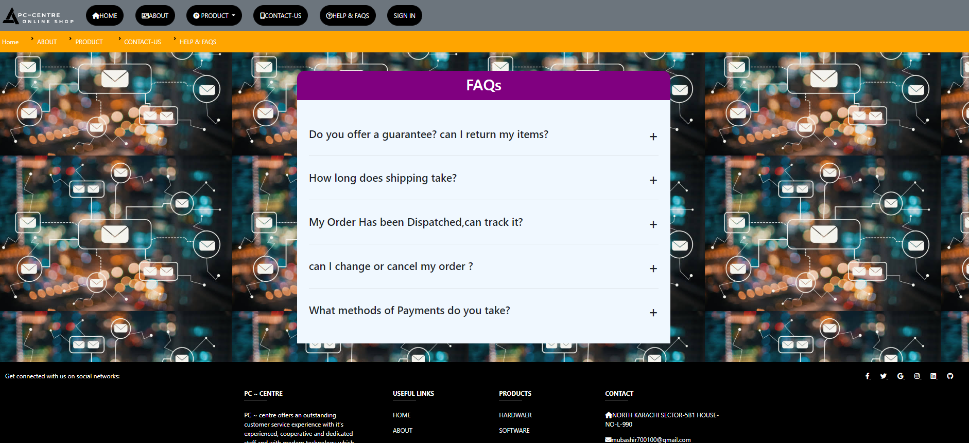

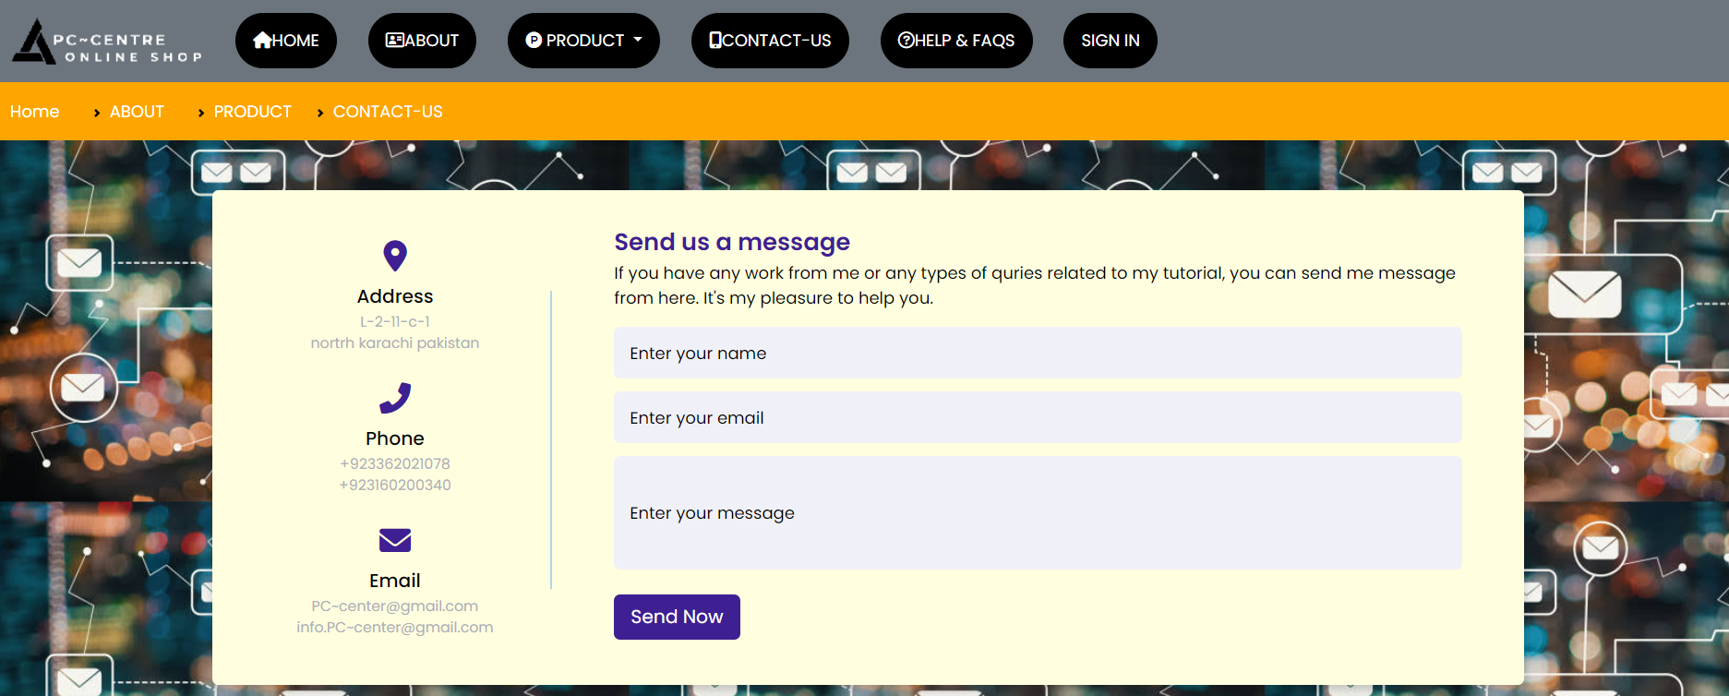



1. **FAQs** (Faqs.html)

* When user click on the **“FAQs”**, he can see this Page as shown below,

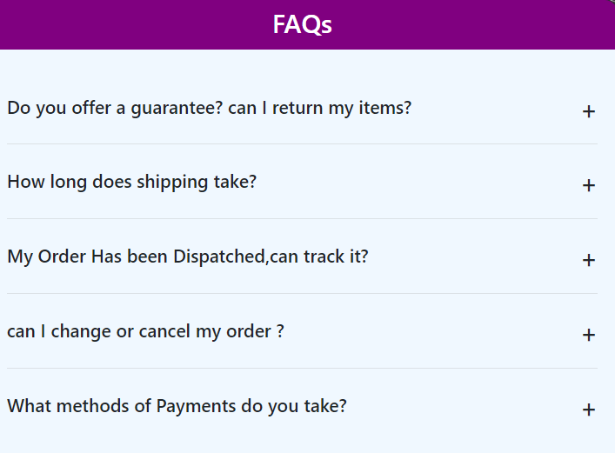

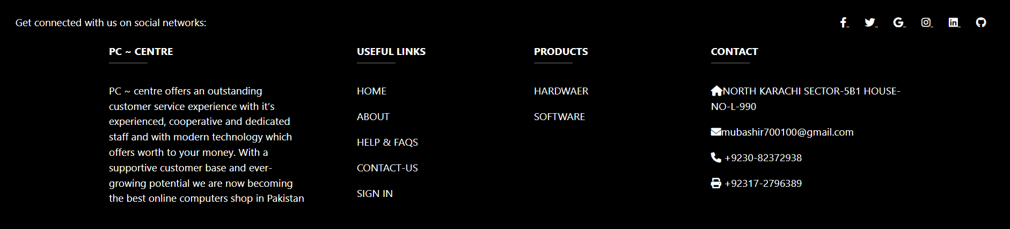

Thank You